EXPERIMENT NO.3

- VHDL CODE:

-- Experiment No 3.- Universal Shift Register
-- Name : Ritesh Machindra Todmal
-- Roll No. : 404C001
-- Teacher Name: Dr.D.G.Ganage
-- Batch : C1

library IEEE;
use IEEE.STD_LOGIC_1164.ALL;

entity shiftregister is
Port( clk,rst : in std_logic;
s : in std_logic_vector(3 downto 0);
m : in std_logic_vector(1 downto 0); -- mode y : out std_logic_vector(3 downto 0) );
end shiftregister;

architecture Behavioral of shiftregister is signal t : std_logic_vector(3 downto 0);

process(clk, rst) begin

if rst = '1' then
y <= "0000";
elsif clk'event and clk = '1' then case m is
when "00" => -- SISO
t(3) <= s(0); -- LSB as input S(0) t(2) <= t(3);
t(1) <= t(2);
t(0) <= t(1);
y(0) <= t(0); -- LSB as output Y(0)

when "01" => -- SIPO
t(3) <= s(0); -- LSB as input S(0) t(2) <= t(3);
t(1) <= t(2);
t(0) <= t(1);
y <= t; -- parallel output

when "10" => -- PIPO
t <= s; y <= t;

when "11" => -- PISO
t <= s; -- 4 bit input S & t <= s
t(2) <= t(3); -- MSB input as t(3) <= S(3)

end if; end process;
t(1) <= t(2);
t(0) <= t(1);
y(3) <= t(0); -- MSB as output Y(3) <= S(3)
when others => NULL;
end case;
end Behavioral;

- VHDL TESTBENCH:

-- Experiment No 3.- Universal Shift Register
-- Name : Ritesh Machindra Todmal
-- Roll No. : 404C001
-- Teacher Name: Dr.D.G.Ganage
-- Batch : C1

LIBRARY ieee;
USE ieee.std_logic_1164.ALL;

ENTITY usr2_tb IS END usr2_tb;
ARCHITECTURE behavior OF usr2_tb IS COMPONENT shiftregister
PORT(
clk : IN std_logic; rst : IN std_logic;
s : IN std_logic_vector(3 downto 0); m : IN std_logic_vector(1 downto 0); y : OUT std_logic_vector(3 downto 0)
);
END COMPONENT;

-- Inputs
signal clk : std_logic := '0'; signal rst : std_logic := '0';
signal s : std_logic_vector(3 downto 0) := (others => '0');
signal m : std_logic_vector(1 downto 0) := (others => '0');

-- Outputs
signal y : std_logic_vector(3 downto 0); BEGIN
-- Instantiate the Unit Under Test (UUT) uut: shiftregister PORT MAP (
clk => clk, rst => rst,
s => s,
m => m,
y => y
);

-- Clock process definitions clk_process : process
begin

end process;

clk <= '0';
wait for 3 ns;
clk <= '1';
wait for 3 ns;

-- Stimulus process stim_proc: process begin

rst <= '1'; wait for 5 ns;
rst <= '0'; wait for 5 ns;

-- Test SISO Mode m <= "00";
s <= "1-0U";
wait for 50 ns;

-- Test SIPO Mode m <= "01";
s <= "1UXX";
wait for 50 ns;

-- Test PISO Mode m <= "11";
s <= "1111";
wait for 50 ns;

-- Test PIPO Mode m <= "10";
s <= "1UU0";
wait for 50 ns; end process;
END;

- SIMULATION RESULT
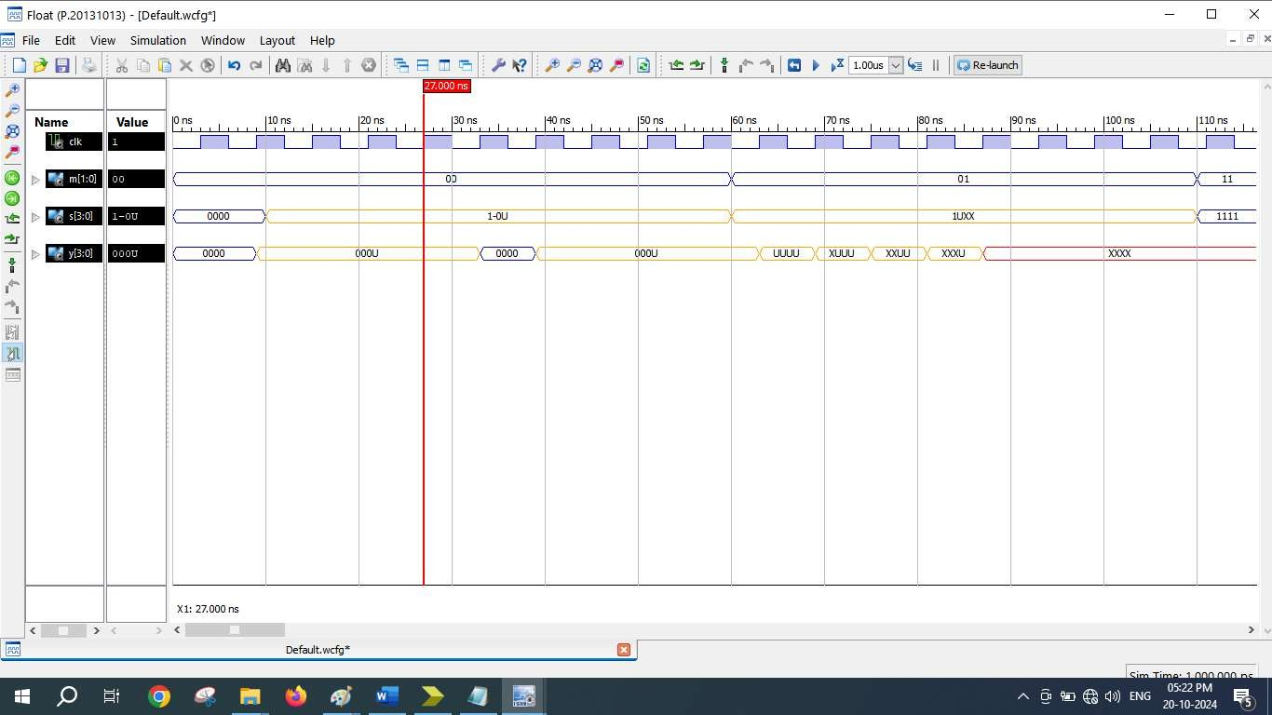
SISO and SIPO
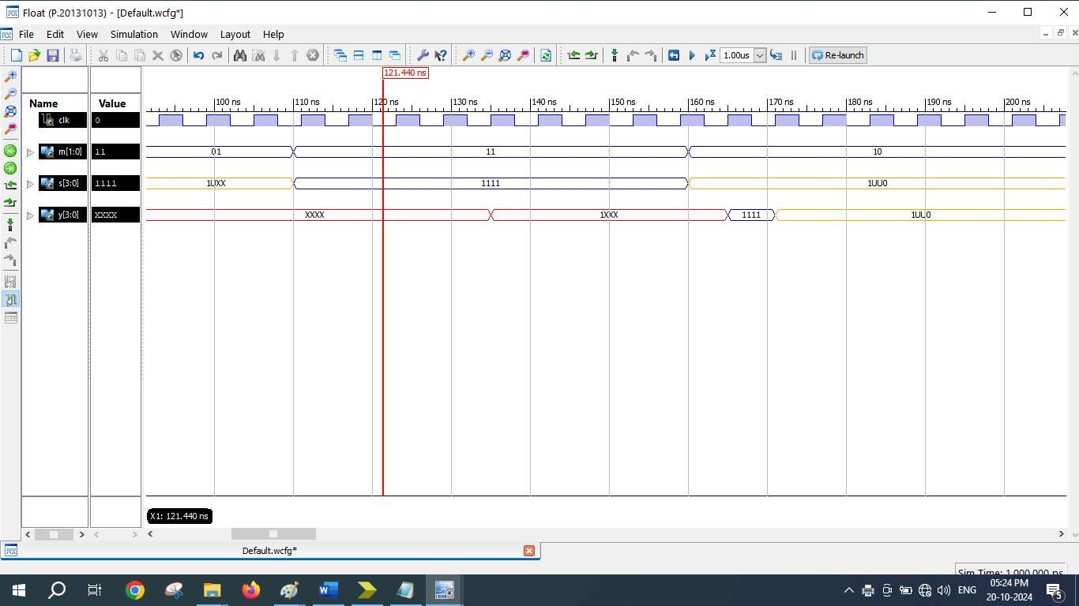
PISO and PIPO

- SCHEMATICS (RTL Technology)
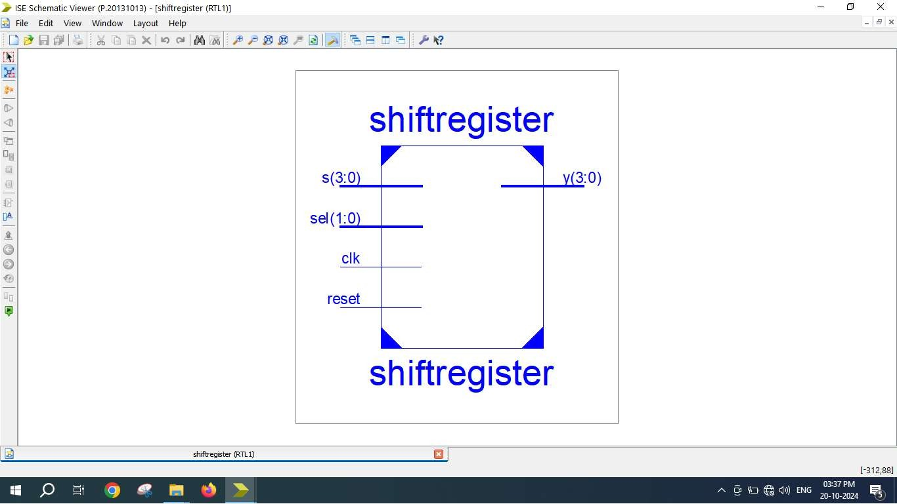
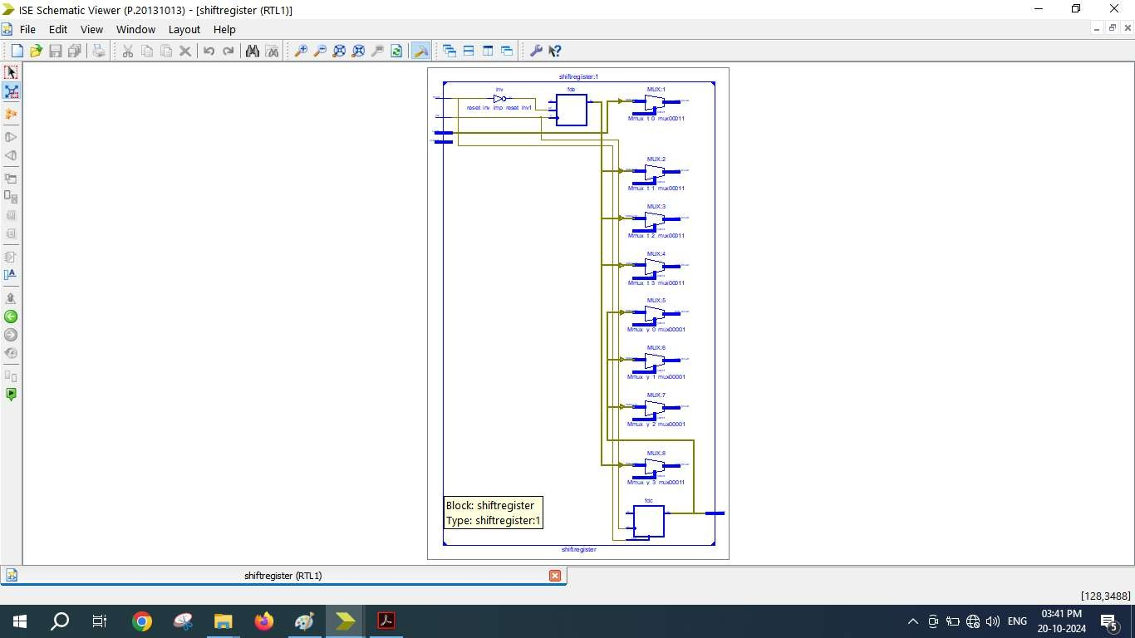

=========================================================================
* Final Report *
=========================================================================
Final Results
RTL Top Level Output File Name : shiftregister.ngr Top Level Output File Name : shiftregister Output Format : NGC
Optimization Goal : Speed
Keep Hierarchy : No
Design Statistics
# IOs : 12
Cell Usage :
# BELS : 11
# INV : 1
# LUT3 : 3
# LUT3_L : 2
# LUT4 : 5
# FlipFlops/Latches : 8
# FDC : 4
# FDE : 4
# Clock Buffers : 1
# BUFGP : 1
# IO Buffers : 11
# IBUF : 7
# OBUF : 4
Device utilization summary:
‐‐‐‐‐‐‐‐‐‐‐‐‐‐‐‐‐‐‐‐‐‐‐‐‐‐‐
Selected Device : 3s250epq208‐5
Number | of | Slices: | 5 | out | of | 2448 | 0%
Number | of | Slice Flip Flops: | 8 | out | of | 4896 | 0%
Number | of | 4 input LUTs: | 11 | out | of | 4896 | 0%
Number | of | IOs: | 12
Number | of | bonded IOBs: | 12 | out | of | 158 | 7%
Number | of | GCLKs: | 1 | out | of | 24 | 4%

‐‐‐‐‐‐‐‐‐‐‐‐‐‐‐‐‐‐‐‐‐‐‐‐‐‐‐
Partition Resource Summary:
‐‐‐‐‐‐‐‐‐‐‐‐‐‐‐‐‐‐‐‐‐‐‐‐‐‐‐
No Partitions were found in this design.
‐‐‐‐‐‐‐‐‐‐‐‐‐‐‐‐‐‐‐‐‐‐‐‐‐‐‐

